**5.3 DATASET**

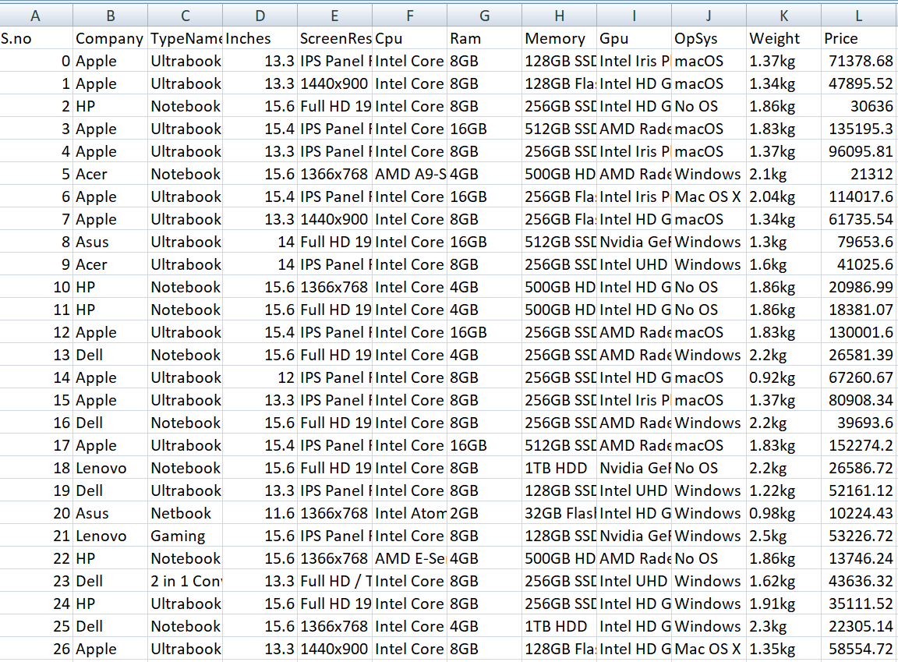

**5.4 CODE**

Laptop price prediction is an important application of machine learning algorithms. Many researchers have proposed various machine learning models to predict the price of laptops, In this literature survey, we will discuss some of the recent studies that have been conducted on laptop price prediction using ML algorithms:

Ice Cream Parlor Solution

Engineers' environmental con

1. "Laptop Price Prediction Using Machine Learning Techniques" by S. Sangeetha and M. Saravanan, International Journal of Innovative Research in Computer and Communication Engineering, Vol. 5, Issue 2, February 2017,

This study proposed a laptop price prediction model using machine learning techniques. The authors collected data from online stores such as Amazon and Flipkart and used various machine learning algorithms such as decision tree, random forest, and support vector machine (SVM) to predict the price of laptops. The study found that the random forest algorithm performed better than the other two algorithms in terms of accuracy.

2. "A Machine Learning Approach to Predict the Price of Laptops" by M. V. Hemanth Kumar and M. R. K. Krishna, International Journal of Computer Applications, Vol. 180, No. 41, December 2018

This study proposed a machine learning approach to predict the price of laptops. The authors collected data from various online stores and used a gradient boosting algorithm to predict the price of laptops. The study found that the proposed approach achieved better accuracy than other traditional machine learning algorithms.

3. "Price Prediction of Laptops using Machine Learning Algorithms" by J. Balamurugan, M, N, Giri Prasad, and B. Praveen Kumar, International Journal of Innovative Technology and Exploring Engineering, Vol. 8, Issue 7, May 2019: This study proposed a price prediction model for laptops using machine learning algorithms such as linear regression, decision tree, random forest, and SVM. The authors collected data from various online stores and compared the performance of these algorithms. The study found that the random forest algorithm performed better than the other three algorithms in terms of accuracy.

4. "Laptop Price Prediction Using Deep Learning Techniques by A. Bansal and R. Kumar, International Journal of Computer Sciences and Engineering, Vol. 7. Issue 3, March 2019

This study proposed a deep learning-based approach to predict the price of laptops. The authors used a convolutional neural network (CNN) to predict the price of laptops. The study found that the proposed approach achieved better accuracy than other traditional machine learning algorithms.

In conclusion, there are many studies that have been conducted on laptop price prediction using machine learning algorithms. These studies have shown that machine learning algorithms can be used to accurately predict the price of laptops. The choice of algorithm depends on the specific problem and dataset